**Testimony of**

**Kevin Outterson**

**Boston University School of Law**

**To**

**The House Energy and Commerce Committee**

**September 19, 2014**

Thank you for inviting me to testify today. My name is Kevin Outterson. I am Professor of Law and the N. Neil Pike Scholar of Health and Disability Law at Boston University. For a decade I have worked on the legal ecology of antimicrobial resistance.[1] I serve as a member of the CDC Antimicrobial Resistance Working Group and a Visiting Fellow at the Royal Institute of International Affairs at Chatham House in London. I speak today in my individual capacity, not representing any institution.

We must act decisively to fix the broken business model for antibiotics and other methods to prevent and treat bacterial diseases. These other methods include vaccines, diagnostics, infection control, and devices.

Last year, the CDC issued the first national threat assessment on antimicrobial resistance.[2] The media reported that 23,000 Americans die each year from antibacterial resistance, but the CDC estimated an additional 14,000 deaths per year from a horrible intestinal disease related to antibiotic use, *Clostridium difficile*. These calculations are conservative and likely undercount the true impact in the US, the equivalent of a 100-passenger jet crashing every day (Fig. 1).

Source: National Vital Statistics Report (NVSR) “Deaths: Final Data for 2011.” Data for ABR is from CDC, Antibiotic Resistance Threats in the US, 2013

Antibiotic resistance deaths in Europe are in the same range,[3] but the situation in poorer countries is also dire. Resistant pathogens in low-income countries cause several hundred thousand neonatal sepsis deaths each year.[4] Similar numbers of people die in low-income countries from susceptible bacteria, so we face an antibiotic access crisis in addition to the global problem of resistance.[5] Much of our world lives in a pre-antibiotic era.

Future projections are much worse. If we lose antibiotics as a drug class, the social cost may be more than a trillion dollars, shaving several years off life expectancy and making many modern medical procedures either impossible or much more dangerous.

The ability to prevent and treat bacterial diseases is a global common pool resource of immense value, akin to fisheries.[6] Exhausting this resource is cheap and lazy; preserving it will take concerted effort and substantial resources. These future expenditures are an investment in the continued effectiveness of one of the greatest classes of drugs ever discovered. Consider this as an “insurance premium,” protecting us against the post-antibiotic era.

1. **The business model is broken.**

For more than a decade, it has been noted that the net present value (NPV) of antibiotic investments was too low, especially compared with other investment opportunities within drug companies.[7] Several larger companies abandoned antibacterial development over the past two decades, although several are now considering re-entry due to the prospect of aggressive action by Congress and the EU.

In order to understand these issues, The Department of Health and Human Services contracted with the Eastern Research Group in October 2011 for a study entitled: *Incentives for the Development of New Drugs, Vaccines, and Rapid Diagnostics for Bacterial Diseases.[8]* I served as an independent consultant and co-author of the final report: *Analytical Framework for Examining the Value of Antibacterial Products* (April 2014). [9]

**A. Private and social net present values (NPVs).**

We were first asked to estimate NPVs for new drugs to treat six specific types of infections, a bacterial vaccine against ear ache, and a new MRSA diagnostic device. This is the “private” NPV because it is calculated from the perspective of the private company making an investment decision on funding R&D. We built a model based on point estimates from the published and grey literature, and also ran Monte Carlo simulations using a range of values. The model, data sources and methods are described in full in the ERG Report. Limitations include focusing solely on the US market and examining a limited set of bacterial indications, vaccines and diagnostics.[10]

We set a benchmark target of a NPV equal to or exceeding $100 million, which is a conservative target for a new antibiotic drug.

We also estimated the direct social value of each of these products – what they bring to society in terms of avoided mortality, morbidity and associated costs. We avoided speculative social values, such as the reductions in resistance that might flow from decreased antibiotic use. We also did not include social costs entirely external to the health system, such as the effects on business from a pandemic. We discounted these values at a 3% rate, consistent with OMB guidelines, with a sensitivity analysis ranging from 1% to 7%. The result is the “social” NPV, what the innovation is potentially worth to society.[11]

The results are striking: in no case did any of the six antibiotic drugs yield a private NPV close to the benchmark $100 million. For all six antibiotics, the 90% confidence interval included *negative* NPVs (Fig. 4 in the ERG Report):

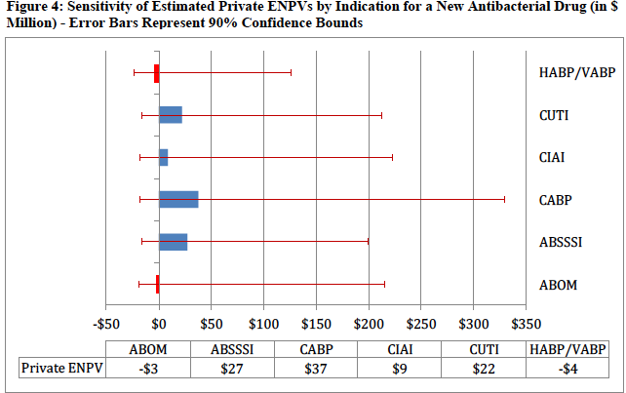

The low private NPVs stand in sharp contrast to the social NPVs, which were conservatively estimated to range from $487 million to $12.1 billion (Fig. 6 in the ERG Report):

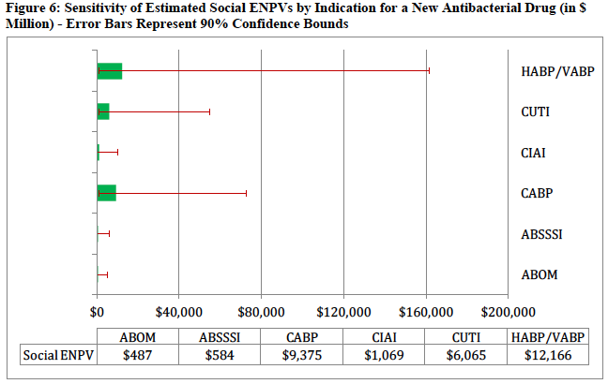

Source: ERG 2014 (fig. 6).

Put simply, society will benefit greatly from preventing or treating these conditions, but companies are not financially rewarded for bringing these products to market and the US health care system is not rewarded for preventing these infections through other means, such as vaccination, better diagnostics or infection control.

The gap between private and social NPVs is even starker when plotted on the same scale, which makes the blue private NPV difficult to see since it is so small compared to the social NPV (Fig. 2):

Fig. 2: Private and social NPVs

Source: Author’s analysis using data from ERG 2014.

The data were more encouraging for the proposed Acute Bacterial Otitis Media (ABOM) vaccine against ear aches. Private NPV was $515 million and social NPV was $2.2 billion,[12] but this social value did not include the ancillary benefits from reducing antibacterial use in children for ABOM, which accounts for about half of all antibiotic use in children.[13] Otitis media accounts for more than 25% of all physician office visits where an antibiotic was prescribed for patients 14 years old and younger.[14] If the vast majority of these prescriptions could be avoided through a vaccine or device, resistance could be slowed, reducing the need for new antibiotics.

The social value gap was greatest for the proposed rapid point-of-care diagnostic for MRSA: private NPV of $329 million and social NPV of $22.1 billion.[15]

Put bluntly, the US should be willing to pay up to $2.2 billion for an ABOM vaccine (or, alternatively, a device that treated ear aches in children without antibiotics such as the EntraTympanic device currently moving towards clinical trials).[16] The US should be willing to pay up to $22.1 billion for an outstanding MRSA diagnostic that changed clinical practice. A prize of $500 million would be a bargain. The largest current prize offered for a bacterial diagnostic is the UK Longitude Prize for £10 million.[17]

**B. Which incentives work best?**

The second main task in the ERG Report was to model which incentives would most efficiently improve private NPV. We searched all of the published literature, including reports by industry, the WHO, think tanks, academics, civil society, and trade associations. We categorized each incentive according to how it might impact NPV.

For example, shortening clinical trials impacts the model in two ways: reducing expenditures and shortening the time until drug approval and sales revenue. Intellectual property extensions delay generic competition, protecting a portion of sales after the patent would have otherwise expired. Tax incentives and non-dilutive capital like the BARDA Broad Spectrum Antibacterial Program reduce cash outlays and the overall cost of capital for the company.

We also modeled how public health and conservation programs impacted private NPV. Many excellent public health programs reduce unit sales of antibiotics, worsening the business case. Examples include successful antibacterial vaccination campaigns (such as the proposed ABOM vaccine), rollout of point-of-care clinical diagnostics (such as the proposed MRSA diagnostic), entry of a device that dramatically cut antibiotic use (such as a device like the EntraTympanic), Medicare programs to reduce hospital-associated infections, and successful public education campaigns by the CDC to reduce unnecessary antibiotic use (see below). All of these are excellent ideas, preventing infections or greatly reducing unnecessary antibiotic use, but each of them reduces market demand for antibiotics and therefore reduces the private NPV (Fig. 3):

Fig. 3: Impact of various incentives on private NPV

|  |  |
| --- | --- |
| **INCENTIVE** | **IMPACT ON PRIVATE NPV** |
| Intellectual Property (IP) extensions | Delays generic entry |
| Tax incentives | Decreases cost of capital |
| Modifications to the clinical trial process & approval standards | Reduces time to market |
| Grants for antibiotic research and development | Decreases R&D costs |
| Prizes and product development partnerships (PDPs) | Decreases R&D costs |
| Reductions in demand-side uncertainty | Reduces demand uncertainty |
| Education campaigns | Reduces unit sales |
| Improvements in hospital infection control | Reduces unit sales |
| Vaccination promotion | Reduces unit sales |
| Better monitoring & reporting of infection rates & antibiotic resistance | Reduces unit sales |
| Performance- and value-based reimbursement schemes | Reduces unit sales |
| Revocation of marketing authorization for antibiotics that pollute | Truncates revenue time horizon |

Source: Adapted from ERG 2014.

The results of our modeling found that several incentives would never reach the $100 million benchmark by themselves. Even perpetual patents and marketing exclusivities failed to reach the benchmark, mainly due to discounting (i.e., the time value of money). When faced with a decision whether or not to green light a new molecule for pre-clinical development, companies do not highly value the prospect of an additional five or ten years of exclusive sales two decades from now. This is especially true for small venture-capital backed research companies.

Shortening clinical trial timeframes was also an unlikely contributor to innovation: clinical trials times would have to be cut by more then 75% in some cases in order to reach the benchmark. Since the ERG model did not account for recent streamlining for antibiotic trials by the FDA, additional reductions on this magnitude are probably impossible. In addition, requiring only very limited trials prior to antibiotic approval will limit the types of efficacy and safety data that physicians and patients need and that payers will want in order to support value-based pricing.

Tax credits, BARDA grants and other non-dilutive capital fared better in the model, as would direct modifications to reimbursement.

The most direct path to improving private NPV is to boost reimbursement, but to do so in a way that does not give any incentive to oversell or waste antibiotics and in a way that does not impede access for patients who truly need the product. When paired with tax credits and BARDA-style contracts, this menu of options can easily exceed the benchmark threshold without surprising payers with extremely high prices.

Perhaps the most important finding in the ERG Report is buried on Table 14: in order to reach the benchmark for one of the bacterial indication (ABSSSI), the total incentives that would be needed totaled $919 million, including additional value-based reimbursements or prizes totaling $155 million after FDA approval. It should be noted that this was just one possible example out of many, but it illustrates an important point: the magnitude of the incentives must be large, in the range of $1 – 2 billion total per year if the goal is to see a couple of new, high-quality antibiotics each year. Since this research has lead times exceeding a decade, substantial incentives must be put in place and left unchanged for more than a decade. Given the high social value of antibiotics, this is a critical social investment, retaining one of the most important drug classes in history.

The proposed DISARM Act, as modified,[18] is an intermediate step to reforming reimbursement, but the sector needs incentives with 10-year federal cost estimates exceeding $10 billion, not $144 million.[19] The size of the response is too low by at least two orders of magnitude.

The magnitude of the incentives required also suggests how much we should be investing in prizes and reimbursement for vaccines that prevent disease and diagnostics that allow physicians to treat each bug with the right drug. Likewise, the NIH budgets for antibacterial resistance research seem too small at an estimated current level of less than $200 million.[20] The CDC has run its national education campaign to reduce unnecessary antibiotic use for many years with less than 2 FTE employees and a total budget under $1 million per year. Much has been achieved under such tight budgets (Fig. 2 in the MMWR article):

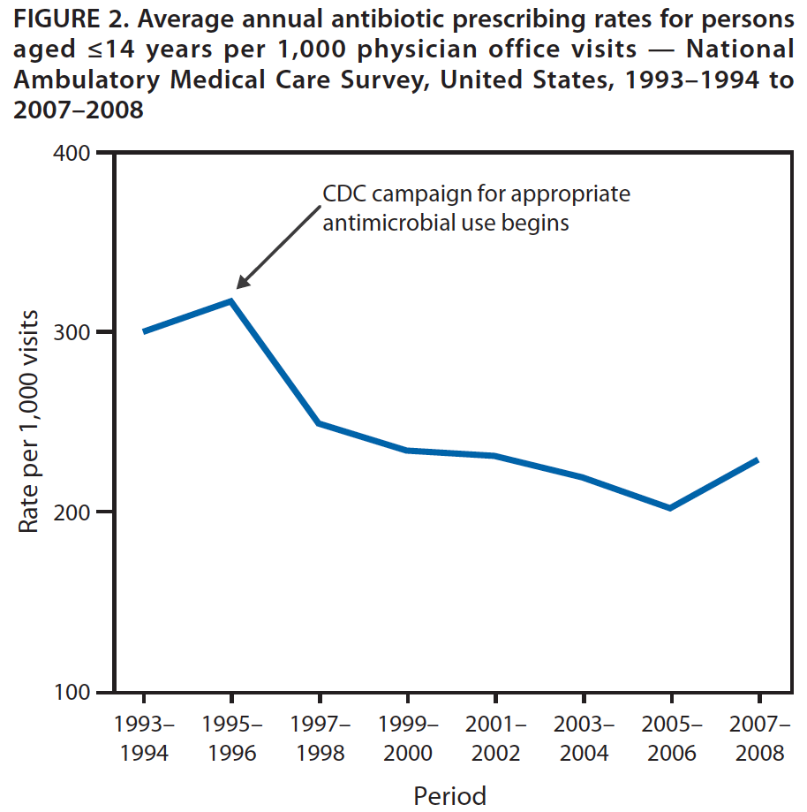

Source: McCaig LF et al. Office-Related Antibiotic Prescribing for Persons Aged ≤14 Years — United States, 1993–1994 to 2007–2008 MMWR 60;34 Sept 2, 2011.

While the GAIN Act is viewed as a good first step, we now know that decisive action is needed, giving investors a credible expectation that if they fund research programs today, then billion dollar rewards await a decade from now.

1. **Now is the moment for decisive action.**

Many lawmakers and stakeholders on both sides of the Atlantic are engaged with the problem of antibacterial resistance. US efforts include the 21st Century Cures hearings, the 2012 GAIN Act, the CDC Threat Assessment, ongoing work by CMS to reduce hospital-associated infections, the impending report from the President’s Council on Science and Technology, BARDA’s contractual program, FDA initiatives, and the soon to be announced NIH National Strategy. Together, they speak to the commitment by the US government to leadership on this issue. Private stakeholders include the Infectious Diseases Society of America, the Alliance for the Prudent Use of Antibiotics, and many others that have long argued for better policies in this area. The Brookings Institution and the Pew Charitable Trusts have hosted several stakeholder meetings to build consensus. Many of the companies are working together and putting concrete legislative language on the table, most prominently through the Antimicrobial Innovation Alliance.

The European Union has committed almost €700 million to a public-private partnership to boost innovation to prevent and treat bacterial diseases, the “New Drugs for Bad Bugs” (ND4BB) program under the larger Innovative Medicines Initiative. One project under ND4BB will specifically examine the broken business models in this area and propose solutions. This project, DRIVE-AB, launches next month and I serve as a Senior Consultant. We will build on the ERG model in the European context, with a significant program of research over the next three years. DRIVE-AB is funded at more than €6 million for the next three years.

Recognizing the urgency, Prime Minister David Cameron recently announced an independent commission headed by economist Jim O’Neill to recommend changes to the economic landscape. Commission staff members will be in Washington next week (September 23-25) to meet with key leaders and researchers in the US. Their preliminary report is due in April 2015, so the timeline is short. The commission is independent of the government, funded by the Wellcome Trust. This work builds on the advocacy carried out for many years by Dame Sally Davies, the Chief Medical Officer of England, both in Europe and at the WHO.

Chancellor Angela Merkel is the third leader of the G7 to highlight the urgent need to act on this issue. She is joined by many civil society organizations in Europe calling for reforms, such as ReACT and Antibiotic Action. Amongst the think tanks in Europe, the Royal Institute of International Affairs (Chatham House) has worked for several years designing new business models for antibiotics.[21] The final report from their Working Group – which I lead – will be published in November 2014.

Clearly, we have unprecedented political, social, and medical mobilization to address antibiotic resistance. This level of energy and consensus has never been seen on this issue. If we do not act now, we may waste the opportunity for a generation.

1. **Specific recommendations.**

The following recommendations are drawn from my work as a researcher and my experience on the various bodies with whom I am privileged to serve, but the recommendations are my own.

* **Be bold**

Now is not the time for small, incremental tinkering. Press reports suggest that some large drug companies are considering leaving antibacterial development; others that cut back programs a decade ago are expressing interest again. But the ERG Report clarifies the scale of the ambition needed: billions, not millions, committed for decades, not years.

* **Think beyond the pill**

New antibiotics are needed. They will cost us perhaps a billion dollars each and be worth every penny. But we should think beyond the pill and also invest similar amounts of money in bacterial vaccines,[22] diagnostics and other devices, basic NIH research, surveillance, and infection control. Bacterial vaccines have a clear impact on health, reducing the need for antibiotics by preventing infections.

Global surveillance is our early-warning system against bacterial threats. Infection prevention and control in hospitals, long-term care, and other institutional settings may be our most cost-effective response (see the decline in hospital-associated MRSA in recent years), but to a hospital CFO, infection control is a cost center, not a revenue generator. When faced with the investment choice between a new cardiac catheterization lab or better infection control, only the catheterization lab offers a return on investment. If we really want to see robust infection control, give it a billing code.

Reimbursement is low and unattractive for antibiotics, but it is worse for diagnostics. Remember that the social value of a MRSA diagnostic is estimated at $22.1 billion. A $500 million dollar prize would draw significant interest and be a bargain. New diagnostic and device companies struggle to raise $3.5 million for an initial round of financing to proceed to clinical trials.

The goal is to prevent and treat bacterial infections. We should fund and use all of the tools, focusing on the most cost-effectives options. The most cost-effective response might be to prevent infections and slow resistance and roll out new antibiotics only when needed. We need innovation not just for new pills, but also to preserve and extend effective treatments, including prevention.[23]

* **Target the incentives**

Resist the Lake Wobegon temptation to see all antibiotics as above average and worthy of special incentives. Since our resources are limited, we must target the most important pathogens identified on the CDC Threat Assessment.

The Qualified Infectious Disease Product (QIDP) list promulgated under the GAIN Act includes every major bacterial pathogen and does not require that the pathogen be resistant. As a result, all *staphylococcus* species are included, as are all *E. coli*. It seems likely that every antibiotic ever approved by the FDA would qualify as a QIDP. This is a failure to prioritize and put scarce resources where they are needed most.

The 1980s saw the introduction of a large number of antibiotics, but many were low quality drugs that never made a significant clinical or commercial impact. Of the 61 new molecular antibiotics approved by the FDA from 1980 – 2009, 43% of them were withdrawn from the market by FDA action or discontinued by the company ceasing commercial sales in the US (Figure in Appendix A). We want quality, not quantity, focused on the greatest threats to human health.

* **Offer a menu of generous incentives across the product life cycle**

Boosting NIH funding stokes the pipeline and feeds start-up companies. Creating tax credits for qualified clinical trial expenses (similar to the Orphan Drug Act, but built on a different statute) will lower the cost of capital and raise NPVs. BARDA is a proven success story, with a strong hand in many of the best molecules now in development (see Fig. 4). BARDA funding should be replenished, with a more flexible mandate.

Fig. 4: BARDA’s Broad Spectrum Antibiotic Supported Product Pipeline, 2014.

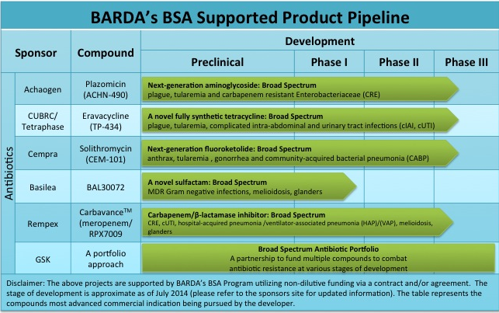

Source: BARDA.

Once products are registered, some form of value-based reimbursement or prize should kick in, either fully replacing or supplementing existing reimbursement. GlaxoSmithKline has publicly taken the stance that volume-based reimbursement is inappropriate for antibiotics due to resistance and has called for post-approval payments that are “delinked” from sales volume. The Chatham House Working Group that I lead has been working on delinkage models for more than a year and will issue a final report in November 2014.

* **National leadership with global coordination**

National programs have successfully reduced antibiotic use, reduced hospital-associated infections, vaccinated the populations, and improved the bacterial safety of water and food.

The US can also lead the world by supporting innovation as described above, especially if this is coordinated with the EU. The market heft of the US and the EU together are more than sufficient to drive substantial research programs to solve these problems.

But some issues require global coordination, since pathogens respect no borders. The global spread of CRE strains is but one example:



KPC-3 producing CRE strains are now found in South Dakota, where an outbreak recently struck.[24]

Global coordination is needed to protect important antibiotics from wasteful overuse. US leadership will be key to this effort, coordinating with partners such as the EU, the G7, and WHO. While TATFAR is a useful arrangement, the level of coordination needed is much greater, with very senior leadership.

* **Include agriculture and environmental sources**

Agriculture accounts for more than 80% of antibiotic use in the US, including some key human drug classes (Fig. 5):

Fig. 5: Total Antimicrobial Consumption by Class in the US[25]

|  |  |  |  |  |  |  |  |
| --- | --- | --- | --- | --- | --- | --- | --- |
| **Antimicrobial Class** | **Animal Use (Kg)** | **Human Use (Kg)** | **Total Use (Kg)** | **Average DDD (g)** | **Total Animal Usage (DDD)** | **Price ($/kg)** | **Animal Expenditures** |
| Aminoglycoside | 214,895 | 6,485 | 221,380 | 0.599 | 358,457,048 | $28.5 | $6,124,507.5 |
| Cephalosporins | 26,611 | 496,910 | 523,521 | 2.77 | 9,606,859 | $75 | $1,995,825 |
| Ionophores** | 4,123,259 | na | 4,123,259 | 1.56 | 2,644,227,099 | $30 | $123,697,770 |
| Macrolides | 582,836 | 164,028 | 746,864 | 1.07 | 544,706,542 | $55 | $32,055,980 |
| Lincosamides | 190,101 | 71,455 | 261,556 | 1.65 | 115,212,727 | $50 | $9,505,050 |
| Penicillins | 880,163 | 1,460,421 | 2,340,584 | 3.76 | 234,085,904 | $30 | $26,404,890 |
| Sulfas | 371,020 | 481,664 | 852,684 | 1.91 | 194,251,309 | $33 | $12,243,660 |
| Tetracyclines | 5,642,573 | 113,832 | 5,756,405 | 1 | 5,642,573,000 | $28 | $157,992,044 |
| Not independently reported*,** | 1,510, 572 | na | 1,510,572 | 1.56 | 968,722,900 | $30 | $45,317,160 |
| **Total:** | 13,542,030 | 3,289,175 | 16,831,205 |  | 10,711,843,388 |  | $246,321,956.5 |

Source: Aidan Hollis, Ziana Ahmed, The path of least resistance: paying for antibiotics in non-human uses, Health Policy, Available online 8 September 2014, ISSN 0168-8510, <http://dx.doi.org/10.1016/j.healthpol.2014.08.013>.

Resistance genes have been found throughout the agricultural sector, including dairy cows that did not receive antibiotics.[26] We should launch serious research efforts to find and deploy techniques to reduce the need for antibiotics in agriculture and to reduce health risks to humans, including animal husbandry, vaccines, alternative forms of growth promotion, and other innovations. The FDA recently brokered voluntary restrictions on non-therapeutic antibiotic uses in farm animals. One recent proposal suggests a user fee on animal antibiotics, to gently reduce volumes while funding research.[27]

Antibiotic pollution is also found in surprising places in the natural environment. Several recent studies have found both antibiotics and resistance genes in wastewater from treatment plants and generally in the water supply.[28] Antibiotics are generally excreted through urine and may survive current water treatment processes. Much work is needed to understand the scope of the problem and to provide innovative water treatment solutions for these issues.

1. **Conclusion.**

Currently in the news and foremost on our minds is Ebola. Ebola is a viral disease, but the next pandemic could be bacterial and arise in our own hospitals and communities. In the movies, heroic research scientists discover the cure before the credits roll; in real life, research programs require at least a decade and generally longer to deliver an effective antibiotic. Congress should take bold action to retain the effectiveness of the original wonder drugs that have saved so many lives – antibiotics.

**APPENDIX A**

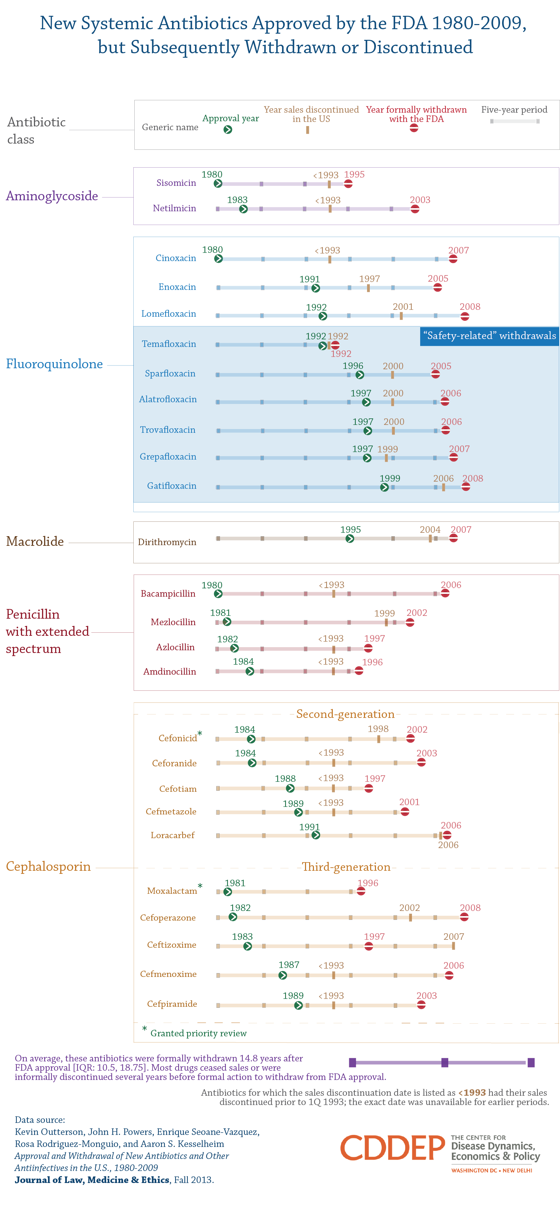

**APPENDIX B**

Kevin Outterson’s publications on resistance and drug regulation:

***Peer reviewed journals, legal journals and major reports:***

*Analytical Framework for Examining the Value of Antibacterial Products* (US Department of Health & Human Services/ASPE, April 15, 2014) (with Sertkaya et al.) <http://aspe.hhs.gov/sp/reports/2014/antibacterials/rpt_antibacterials.cfm>.

*New Business Models for Sustainable Antibiotics,* Chatham House Centre on Global Health Security Working Group Papers (London, Feb. 2014).

*The Drug Quality and Security Act – Mind the Gaps*, 370 N. Engl. J. Med. 97-99 (2014).

*Approval and Withdrawal of Antibiotics and Other Antiinfectives in the US, 1980-2009*, 41(3) J.L. Med. & Ethics 688-696 (2013) (with Powers, Seoane-Vazquez, Rodriguez-Monguio, & Kesselheim).

*Regulating Compounding Pharmacies After NECC*, 367 N. Eng. J. Med. 1969 (2012).

*All Pain, No GAIN: Need for Prudent Antimicrobial Use Provisions to Complement the GAIN Act,* 30 APUA Clinical Newsletter 13 (2012).

*Towards New Business Models for R&D for Novel Antibiotics*, 14 Drug Resistance Updates 88-94 (2011) (with So AD, et al.).

*Improving Antibiotic Markets for Long Term Sustainability,* 11 Yale J. Health Pol’y, L. & Ethics 101 (2011) (with Kesselheim AS).

*Fighting Antibiotic Resistance: Marrying New Financial Incentives to Meeting Public Health Goals*, 29 Health Affairs 1689-1696 (2010) (with Aaron S. Kesselheim).

*Questions About the 10 x ’20 Initiative,* 51 Clin. Infect. Diseases 751-752 (2010) (with Powers JH, Gould IM & Kesselheim AS).

*The Legal Ecology of Resistance: The Role of Antibiotic Resistance in Pharmaceutical Innovation*, 31 Cardozo L. Rev. 613 (2010).

*How Medicare Could Get Better Prices on Prescription Drugs,* 28Health Affairs W832-841 (July 30, 2009, web exclusive) (with Kesselheim AS).

*Death from the Public Domain?*, 87 Texas L. Rev. See Also 45 (2009).

*Foreword – Will HPV Vaccines Prevent Cervical Cancers Among Poor Women of Color?: Global Health Policy at the Intersection of Human Rights and Intellectual Property Law,* 35 Am. J. L. & Med. 247 (2009) (symposium editor).

*Pharmaceutical Innovation: Law & the Public’s Health*, 37 J. L. Med. & Ethics 173 (2009) (symposium editor).

*Should Access to Medicines And TRIPS Flexibilities Be Limited To Specific Diseases?* 34 Am. J. L. & Med. 279 (2008).

*Antibiotic Resistance and Antibiotic Development - Author’s Reply.* 8 Lancet Infectious Diseases 212-214 (April 2008).

*Market-Based Licenses for HPV Vaccines in Developing Countries,* 27 Health Affairs 130 (January/February 2008) (with Aaron S. Kesselheim).

*Will Longer Antimicrobial Patents Improve Global Public Health?*  7 Lancet Infectious Diseases 559-66 (2007) (with Balch Samora & Keller-Cuda).

*Patent Buy-Outs For Global Disease Innovations For Low- and Middle-Income Countries*, 32 Am. J. L. & Med. 159-73 (2006).

*Counterfeit Drugs: The Good, The Bad, and the Ugly*, 16 Albany L. J. of Science & Technology 525 (2006) (with Smith).

*The Vanishing Public Domain: Antibiotic Resistance, Pharmaceutical Innovation and Global Public Health,* 67 Univ. of Pittsburgh Law Rev. 67-123 (2005).

*Pharmaceutical Arbitrage: Balancing Access and Innovation in International Prescription Drug Markets,* 5 Yale J. Health Policy, Law & Ethics 193-286 (2005).

*Agony in the Antipodes: The Generic Drug Provisions in the Australia – US Free Trade Agreement*, 2 Journal of Generic Medicines 316-326 (Spring 2005).

*Free Trade in Pharmaceuticals*, 181 Medical Journal of Australia 260-261 (Sept. 6, 2004).

*Rapid Response to* Editorial, Peter Drahos and David Henry, *The free trade agreement between Australia and the United States*, 328 British Medical Journal 1271 (May 2004) *available at* <http://www.bmj.com/rapid-response/2011/10/30/testimony-us-house-ways-amp-means-committee-australian-us-fta>.

**Book chapters & monographs:**

*Combatting Antibiotic Resistance Through the Health Impact Fund* (with Thomas Pogge (Yale) & Aidan Hollis (Calgary)) in The Globalization of Health Care: Legal and Ethical Issues (Glenn I. Cohen, ed., Oxford University Press, 2013).

*Germ Shed Management in the United States*, in Antibiotic Policies: Controlling Hospital-Associated Infection (with Olga Yevtukhova) (Ian M. Gould and Jos van der Meer, eds., Springer, 2011).

*Disease-Based Limitations On Compulsory Licenses Under Articles 31 and 31 bis,* in Research Handbook on Intellectual Property Law and the WTO (Carlos Correa, ed., Edward Elgar, 2010).

*Import Safety Rules And Generic Drug Markets*, in Import Safety: Regulatory Governance in the Global Economy (Cary Coglianese, Adam Finkel, & David Zaring, eds., 2009) (The University of Pennsylvania Press).

*Global Pharmaceutical Markets*, in A Companion To Bioethics (2nd Ed.) (Blackwell Companions to Philosophy) (Helga Kuhse & Peter Singer, eds.) (Blackwell, 2009) (with Donald Light).

*International Pharmaceutical Issues*, in The Fundamentals of Life Sciences Law: Drugs, Devices, and Biotech (American Health Lawyers Association, 2007).

*Fair Followers: Expanding Access To Generic Pharmaceuticals For Low- and Medium-Income Populations*, in The Power of Pills: Social, Ethical and Legal Issues in Drug Development, Marketing and Pricing (Jillian Clare Cohen, Patricia Illingworth, and Udo Schuklenk, eds.) (London: Pluto Press, 2006).

Translated into Portuguese: *‘Fair Followers’: Expandindo o Acesso a Medicamentos Genéricos para a População de Baixa e Média Renda*, in Propriedade Intelectual: Novos Paradigmas Internacionais, Conflitos e Desafios(Campus-Elselvier, Brasil 2007).

1. A bibliography of my works on resistance is collected in the Appendix.
2. CDC. Antibiotic Resistance Threats in the US, 2013.
3. ECDC. Available at <http://ec.europa.eu/health/antimicrobial_resistance/policy/index_en.htm>.
4. Laxminarayan R et al. (in peer review 2014).
5. My testimony today focuses on bacterial threats. While drug-resistant malaria, tuberculosis and HIV are very significant threats to global health, they are beyond the scope of this testimony.
6. Outterson K. The Legal Ecology of Resistance: The Role of Antibiotic Resistance in Pharmaceutical Innovation. Cardozo L Rev. 2010;31:613.
7. Projan, S.J. 2003. Why is big Pharma getting out of antibacterial drug discovery? *Curr. Opin. Microbiol.* **6:**427–430.
8. Task Order No. HHSP23337004T; Contract No. HHSP23320095634WC.
9. Available at: <http://aspe.hhs.gov/sp/reports/2014/antibacterials/rpt_antibacterials.cfm>.
10. Professor Adrian Towse and Dr. Jorge Mestre-Ferrandiz at the Office of Health Economics have created a similar modeling exercise, currently in peer-review. Their model focuses on Europe and antibiotics targeting narrow-spectrum resistant pathogens. In general, their private NPVs are lower than those described in the ERG Report.
11. ERG Report, section 3.6.
12. ERG 2013 (tables 19-20).
13. Finkelstein JA, Metlay JP, Davis RL, Rifas-Shiman SL, Dowell SF, Platt R. Antimicrobial Use in Defined Populations of Infants and Young Children. [Arch Pediatr Adolesc Med](http://www.ncbi.nlm.nih.gov/pubmed/10768680) 2000; 154(4):395-400.
14. McCaig LF et al. Office-Related Antibiotic Prescribing for Persons Aged ≤14 Years — United States, 1993–1994 to 2007–2008 MMWR 60;34 Sept 2, 2011.
15. ERG 2013 (tables 21-24).
16. See <http://www.entratympanic.com/>.
17. See <http://www.nesta.org.uk/project/longitude-prize-2014>.
18. The modification to limit DISARM incentives to higher-priority pathogens is an excellent choice; see my discussion below on targeting.
19. Avalere Health. Estimated Costs of Developing an Innovative Strategy for Antimicrobial Resistant Microorganisms Act of 2014 (DISARM Act) (draft, June 2014).
20. The NIH releases composite figures for antimicrobial resistance research, which includes anti-retrovirals (HIV) and anti-parasiticals (malaria). The actual amount of NIH funding targeting resistant bacterial pathogens on the CDC Threat Assessment is not known to the public. I have estimated it at $200 million; the actual number may be lower.
21. Outterson K. New business models for sustainable antibiotics. Chatham House 2014. Available at <http://www.chathamhouse.org/sites/files/chathamhouse/public/Research/Global%20Health/0214SustainableAntibiotics.pdf>.
22. Bacterial vaccines such as the pneumococcal conjugate vaccine have substantially reduced invasive pneumococcal disease and therefore antibiotic use. What if we had a vaccine against MRSA or *Clostridium difficile*?
23. Laxminarayan R. Antibiotic effectiveness: Balancing conservation against innovation. Science 2014;345:1299-1301; Kesselheim AS, Outterson K. Improving Antibiotic Markets for Long Term Sustainability. 11 Yale J Health Pol’y L Ethics 2011;11:101.
24. Lee M. Kiedrowski et al. Carbapenem-Resistant Enterobacter cloacae Isolates Producing KPC-3, North Dakota, USA. EID 20;9 (Sept 2014).
25. Notes: Data on quantities from [9,48]. Data on prices are drawn from a search of prices offered on Alibaba in August 2013. DDDs are taken from the WHO ATC/DDD Index 2013 and averaged by class. *Includes aminocoumarins, amphenicols, diaminopyrimidines, fluoroquinolones, glycolipids, pleuromutilins, polypeptides, quinoxalines, and streptogramins. **The DDD is the average of other commonly used antibiotics.
26. Wichmann F, Udikovic-Kolic N, Andrew S, Handelsman J. 2014. Diverse antibiotic resistance genes in dairy cow manure. mBio 5(2):e01017-13. doi:10.1128/ mBio.01017-13.
27. Aidan Hollis, Ziana Ahmed, The path of least resistance: paying for antibiotics in non-human uses, Health Policy, Available online 8 September 2014, ISSN 0168-8510, <http://dx.doi.org/10.1016/j.healthpol.2014.08.013>;
28. Farenfeld N. et al. [Reclaimed water as a reservoir of antibiotic resistance genes: distribution system and irrigation implications](http://www.ncbi.nlm.nih.gov/pmc/articles/PMC3664959/) Front Microbiol. 2013;4:130.